Chapter 13 – Principles of Ecology Lecture Guide, Day 1

What is Ecology?
- It is the scientific study of interactions among organisms and between organisms ________________________________________________________________________________ or surroundings.
The Nonliving Environment - Abiotic factors
- Are the __________________________________________________ of an organism’s environment.
- Examples: _______________________________________________________________________________ light, and soil.
  - Abiotic factors _____________________________________________________ an organism’s life.
The Living Environment – Biotic factors
- Are all of the _________________________________________________________ that inhabit an environment.
- All organisms depend on others directly or indirectly for_________________________________________________ reproduction, or protection.
Habitat versus Niche
- Habitat is the ____________________________________________________ a plant or animal lives.
- Niche is an organism’s total way of life or its ______________________________________ in the environment.
Levels of Organization
- Most basic level of organization is called an _______________________________________________.
  - This is an individual living thing that is made of_________________________________________________________________ responds, grows, and develops.
- ________________________________________ – a ________________________________________________________ to one another that they can breed and produce fertile offspring.
- Other ecologists study __________________________________________________.
  - This is a group of individuals that belong to the ___________________________________________________________________________.
- In addition to populations, ecologists also study ___________________________________________________.
  - This is a _______________________________________________________________ that live in one area, such as a group of alligators, turtles, birds, fish, and plants in the Florida Everglades.
- Ecologists may further decide to study a particular __________________________________________________.
  - This is a collection of all the ____________________________________that live in a particular place, together with their _______________________, or physical environment.
- Larger systems called ________________________________________________ are also studied by ecologists.
  - A biome is a group of ecosystems that have the same ______________________________________ similar dominant _______________________________________.
- Highest level of organization that an ecologist studies is the entire ____________________________________________.
  - Biosphere is the portion of Earth that ____________________________________________________________.
Biodiversity!
- Is the ________________________________________________________________, of living things in an ecosystem.
  - Examples of areas with high biodiversity: ___________________________________________
Relationships in ecosystems
- Changing one factor in an ecosystem can ____________________ many other factors.
- Can cause a ripple effect
Keystone Species
- Is a species that has an _____________________________________________________________ on its ecosystem.
- One example of a keystone species is the _______________________________________________.
- Their use of fallen trees to make dams helps __________________________________________________________ into ponds, wetlands, and meadows.

Review:
Main Idea. An ecosystem includes both biotic and abiotic factors. Use a word from below to complete the following sentences.
Abiotic Animals Biotic
Living Moisture Nonliving
Plants Temperature
- All ecosystems are made up of __________________________ and ___________________ components.
- ________________________ factors are living things, such as ________________________ or ________________________.
- ________________________ factors are nonliving things, such as ________________________, or _______________________.
- What is the term for an organism that has an unusually large effect on its ecosystem?
- What is the difference between a biotic and abiotic factor?
- Place the levels of ecology in order from smallest to largest: ecosystem, population, biosphere, community, and biome
_______ ____________________________

Chapter 13 – Principles of Ecology Lecture Guide, Day 2

Energy Flow in Ecosystems
- ________________________________________________ is the main energy source for life on Earth.
    - Less than _______________________________ is actually used by organisms on Earth.
- Energy flows through ecosystems from __________________________________________________________.
- What is a producer? - It makes its own ___________________________________________________________.
- What is a consumer? Get food by ________________________________________________________________________.
Producers
- Can also be called ____________________________________________.
- “Troph” means _______________________________; “Auto” means _________________________________________.
- Examples: _________________________________________________________________________________
Review: Niche of a Producer
- What is a niche?
  - It is the _____________________________________________ of an organism in the environment.
- Niche of a producer is:
  - ______________________________________________________________________ into organic, stored energy for the use of living organisms.
  - May be a ___________________________________________________ using light energy (means it gets energy from the sun)
  - May be ____________________________________________________ using chemical energy
Photoautotroph
- Is a producer that ________________________________________________________________________ by:
  - _________________________________________________________
Chemoautotrophs
- Capture energy from the ___________________________________________________________ such as hydrogen sulfide.
- This process is called _____________________________________________________________.
- Often occurs in __________________________________________________________________ or guts of animals.
Consumers
- Can also be called _______________________________________________________________.
- “Hetero” means _____________________________________
- Eat other organisms to __________________________________________________________
Types of Consumers
- _____________________________________________________ – eat only plants
- _____________________________________________________ – eat only animals
- _____________________________________________________ – eat both plants and animals.
- _____________________________________________________ – eat detritus, or _____________________________________________________.
- _____________________________________________________ – are detritivores that break down organic matter into simpler compounds.
Consumer Terminology
- Consumers that eat producers to get energy are what we call __________________________________________________.
- In other words they are _________________________________________.
- A consumer that eats another consumer is called a ___________________________________________________.
- Or they may be called __________________________________________________________________________.
- A consumer that eats another consumer that already ate a consumer is what we call a _________________________________________________________________.
Feeding Relationships
- Energy flows through an ecosystem in _________________________________________________.
  - From ___________________________________________________________________.
- Transfer of energy from the sun to producer to primary consumer then to higher order consumers is called a _______________________________________.
Food chains:
- Is a ___________________________________________________________ that links species by their feeding relationships
Food Chain Organizational Levels
- Trophic levels:
  - ______________________________________________________________ in a food chain.
    - Example: ________________________________________________________ has 3 trophic levels.
  - Carnivores are the highest level and producers are the first of a trophic level (where energy enters the system)
  - Energy flows up the food chain from __________________________________________________________ trophic level.
- Trophic levels (More review…):
  - Primary consumers are _______________________________________ (first consumer above a producer)!
  - Secondary consumers are _____________________________________that eat herbivores!
  - Tertiary consumers are _______________________________________ that eat secondary consumers.
Feeding Relationships
- Food webs - are a model that show the ____________________________________________________________________ relationships and the flow of energy within and sometimes beyond an ecosystem.
Review:
Main Idea. Producers provide energy for other organisms in an ecosystem. Complete the following sentences with the correct term.
Autotrophs Eating Nonliving
Consumers Heterotrophs Producers
- ____________________ are organisms that get their energy from ____________________ resources. These organisms are also called __________________________________.
- ____________________ are organisms that get their energy by ____________________ other organisms. These organisms are also called ___________________.
- Why are producers important to an ecosystem?
- What is the difference between a consumer and a producer?
Chapter 13 – Principles of Ecology Lecture Guide, Day 3

Ecological Pyramids
- Is a diagram that shows the relative ________________________________________________________________ contained within each trophic level in a food chain or food web.
- Can be represented in three forms:
  - ________________________________________________________
  - ________________________________________________________
  - ________________________________________________________
Energy Pyramid
- Compares energy used by ________________________________________________________________________.
- Illustrates how available energy is _______________________________________ among the trophic levels in an ecosystem.
Loss of Available Energy
- So when we look at how energy becomes available or is lost, we have to define biomass
  - Is a measure of the _________________________________________________________________.
  - When a consumer eats a producer, a great amount of energy is lost as _______________________________________________!
- The loss of energy between trophic levels can be as great as _______________________________.
  - This means only __________________________ is left to transfer from one trophic level to the next.
Biomass Pyramid
- Compares the ___________________________________ of different trophic levels within an ecosystem
- Provides a picture of the ___________________________________ of producers needed to support primary consumers, the mass of primary consumers to support secondary consumers, and so on…
Pyramid of Numbers
- Shows the __________________________________________ of individual organisms at each trophic level in an ecosystem

Chapter 13 – Principles of Ecology Lecture Guide, Day 4

Water (H₂O) Cycle: _________________ Cycle
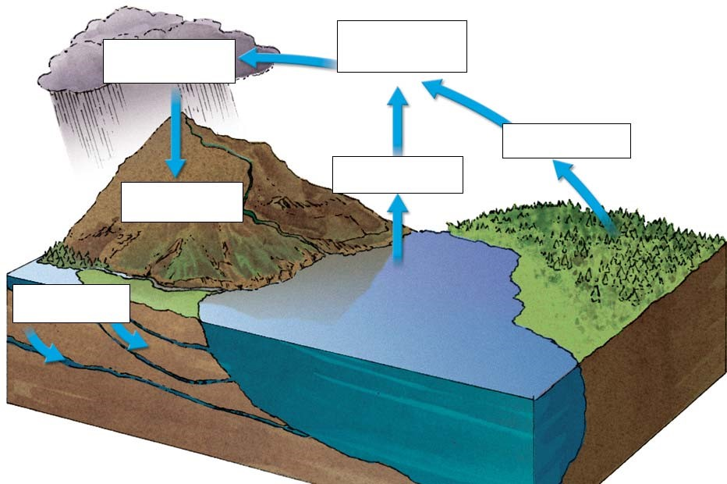
- Defined: _______________________ of _______________________ through the
_______________________ and its _______________________
- _____________ of the Earth is _______________________ in water
- _____________ than _______________________ is _______________________.
- Most water is _______________________ and or _______________________.
Water Cycle Pathway
- Evaporation: _______________ changes _______________ from a ____________________ to a ________
- Transpiration: Water _______________________ from the _______________________ of plants through ____________________ called ____________________
- Water ______________________ starts to ______________________… ______________________ occurs
- Condensation: process where water ________________________ turns into a ______________________
- Precipitation: ____________________, ____________________, sleet, or hail falls when water
____________________ become ____________________
- Runoff: Water ____________________ down ____________________ into ____________________, ____________________, streams, ____________________…
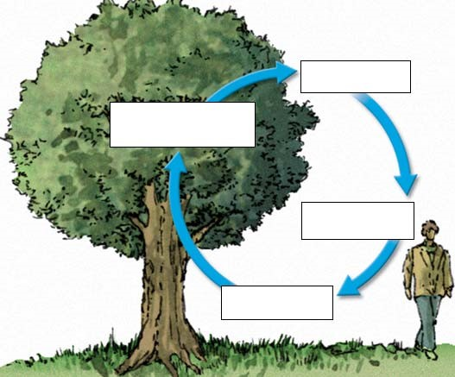
- Infiltration: Water _______________ into the _______________ and collects as _____________________
Oxygen (O₂) Cycle
- Autotrophs: Release _____________________ into
____________________ by ___________________
- Most life needs __________________________ for ____________________ ____________________
– Creates ____________________ (energy) for ________________________

Carbon (C) Cycle
- Plants
  - Absorb _________________________ for
_______________________________
  - Release _________________________ (______________________________) after photosynthesis
- Animals
  - _______________________ passed _______ the food _______________________
  - _______________________ exhaled into _______________________
- Decomposers
  - __________________ glucose by _____________________ on _____________________ organisms
  - _______________________ released in their _______________________
- Human Contribution
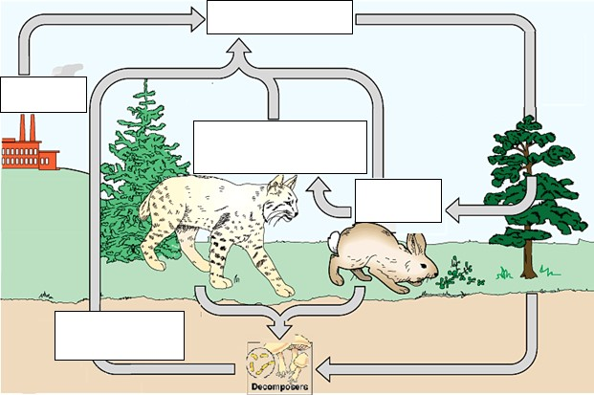
  - Release _____________________ CO₂ into _____________________ when ___________________ _______________ (coal, oil, natural gas) are _________________ for _____________________

  - Cycle is
__________________________of __________________________

Phosphorus (P) Cycle
- Phosphorus ____________________ to make _____________, ______________, ____________________
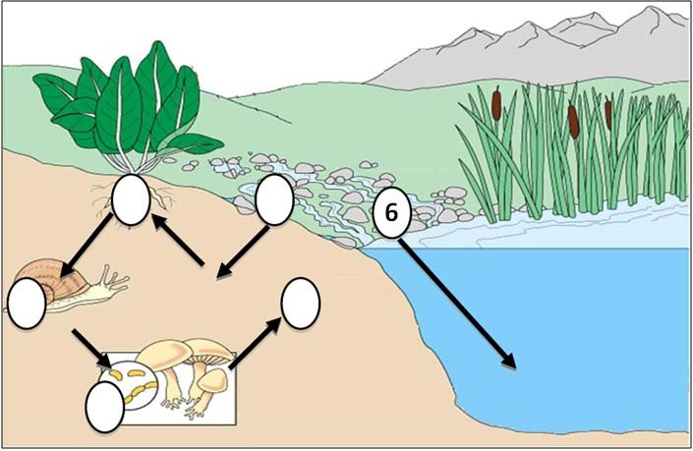
- Problem: _________________________ phosphorus in ______________________________
- Step 1: Phosphorus _______________________ by _______________________ of ___________________
- Step 2: _____________________ absorb _______ through their _____________________
- Step 3: _____________________ ingest _______
- Step 4: _____________________ obtain _______ when ________________________ on ______________ organisms
- Step 5: Decomposers _______________ P within ________________ back into _______________ or water - Cycle _____________________

• Human Contribution
- Adding _______________________ P from _______________________
- P _______________________ into _______________________, etc…
- _______________________ P _______________________ extreme ________________________
& _______________________ growth

Nitrogen (N) Cycle
- Nitrogen ____________________ to build _____________________ acids (__________ / __________)
- Problem: Nitrogen in atmosphere (____________) is ______________________
- Step 1: ________________ in ________________ convert __________ into ____________________ forms –
- Step 2: Bacteria ______________________ usable _______
- Step 3: ______________________ release _______ as _______________ into ____________________
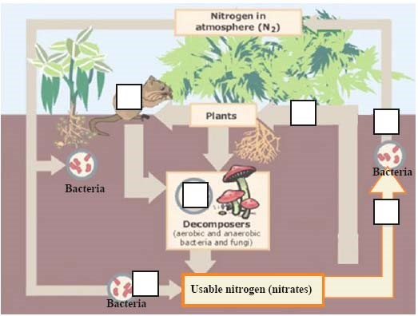
- Step 4: ______________________ absorb _______ through their ______________________

- Step 5: ______________________ ingest _______ through the food ______________________
- Step 6: ______________________ obtain _______ from _____________________ organisms…
return _______ to ________________ in their ____________________
How does _______________________ help?
- Energy _______________________ atmospheric ________________________ into Nitrogen ____________________
- ______________________ oxide falls in ______________________ to _______________________

Review Questions:

- Name and define the 6 stages of the water cycle.
- How is oxygen released into the atmosphere?
- In which cellular process is oxygen removed and used from the atmosphere?
- In which cellular process is carbon dioxide released into the atmosphere?
- How are humans disrupting the carbon cycle?
- Which objects release phosphorus over time?
- How are humans disrupting the phosphorus cycle?
- Which organisms help convert gaseous nitrogen into a usable form of nitrogen in the nitrogen cycle?
- How do plants obtain nitrogen?

