IB Biology Chapter 3 Notes: Genetic Modification & Biotechnology (3.5) NAME:

Word | Definition
PCR | Polymerase chain reaction—a DNA technology that is used to amplify small pieced of DNA
Gel electrophoresis | A technique used for the separation of DNA or protein based on size and charge of the molecules.
DNA profiles/DNA fingerprinting | The analysis of a small amount of genetic material from a blood or cell sample, which is unique per individual and can aid in identification.
Genome | The complete set of genetic material of an organism
Plasmid | A circular piece of DNA found in bacteria
DNA ligase | An enzyme used to combine (“glue”) pieces of DNA together. It joins together the sugar phosphate backbone of DNA segments.
Restriction enzymes (endonucleases) | Enzymes that cut DNA at a specific sequence.
Recombinant DNA | DNA that had has been artificially modified to contain a gene from a different organism/species.
Genetically modified organisms (GMO) | An organism that has been genetically engineered so that the DNA of the organism has been altered. Generally this is an organism that contains recombinant DNA.
Clone | An organism whose DNA is identical to another organisms.  Clones can be natural clones (example: organisms that asexually produce) or clones that are created in laboratories.
Somatic cell nuclear transfer | The process of making a clone in a lab from the nucleus of a somatic (body) cell. Scientists replace the nucleus of an egg with the nucleus from a body cell and then cause the egg to start dividing.
Therapeutic cloning | A procedure where damaged tissues or organs are repaired or replaced with genetically identical cells that come from stem cells.

3.5.1 Gel electrophoresis is used to separate proteins or fragments of DNA according to size and charge.

3.5.2 PCR can be used to amplify small amounts of DNA.

3.5.3 DNA profiling involves comparison of DNA.

7.1.8 Explain how tandem repeats are used in DNA profiling.

3.5.9 Use of DNA profiling in paternity and forensic investigations.

3.5.14 Analysis of examples of DNA profiles.

Describe the mechanism of gel electrophoresis:

What factors are used to separate protein samples or DNA fragments?

Outline the steps involved in DNA profiling:

Use in forensic investigations:

Use in paternity investigation:

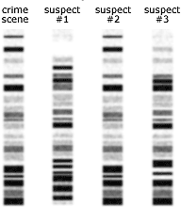

Which of the three suspects matches the blood sample found at the crime scene based on the DNA profile, right?

3.5.4 Genetic modification is carried out by gene transfer between species.

3.5.10 Gene transfer to bacteria with plasmids using restriction endonucleases (enzymes) and DNA ligase.

3.5.11 Assessment of the potential risks and benefits associated with genetic modification of crops.

Describe what occurs in genetic modification:

Examples:

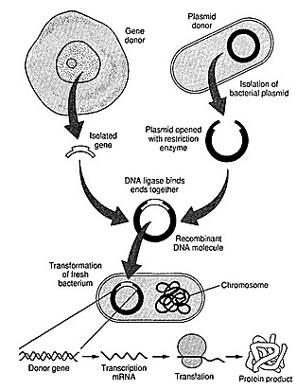
Outline how genes are transferred between organisms using plasmids, restriction endonucleases, and DNA ligase:

Benefits of GM crops:
Environmental:

Health:

Agricultural:

Risks of GM crops:
Environmental:

Health:

Agricultural:

3.5.15 Analysis of data on risks to monarch butterflies of Bt crops.

3.5.5 Clones are groups of genetically identical organisms, derived from a single original parent cell.

3.5.6 Many plant species and some animal species have natural methods of cloning.

3.5.13 Design an experiment to assess one factor affecting the rooting of stem cuttings.

3.5.7 Animals can be cloned at the embryo stage by breaking up the embryo into more than one group of cells.

3.5.8 Methods have been developed for cloning adult animals using differentiated cells.

3.5.12 Production of cloned embryos by somatic cell nuclear transfer.
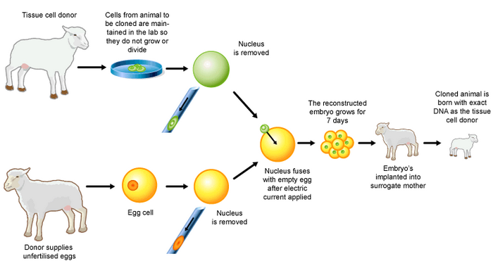

List examples of naturally-occurring clones:

What is a stem-cutting?

What are possible factors that could be investigated?

Describe how embryo ‘splitting’ or ‘fragmentation’ can produce clones:

Outline how Somatic Cell Nuclear Transfer (SCNT) is used to produce clones:

