Understandings, Applications and Skills (This is what you maybe assessed on)

 | Statement | Guidance
1.1.U1 | According to the cell theory, living organisms are composed of cells.
1.1.U2 | Organisms consisting of only one cell carry out all functions of life in that cell. | Students are expected to be able to name and briefly explain these functions of life: nutrition, metabolism, growth, response, excretion, homeostasis and reproduction.
1.1.U3 | Surface area to volume ratio is important in the limitation of cell size.
1.1.U4 | Multicellular organisms have properties that emerge from the interaction of their cellular components.
1.1.U5 | Specialized tissues can develop by cell differentiation in multicellular organisms.
1.1.U6 | Differentiation involves the expression of some genes and not others in a cell’s genome.
1.1.U7 | The capacity of stem cells to divide and differentiate along different pathways is necessary in embryonic development and also makes stem cells suitable for therapeutic uses.
1.1.A1 | Questioning the cell theory using atypical examples, including striated muscle, giant algae and aseptate fungal hyphae.
1.1.A2 | Investigation of functions of life in Paramecium and one named photosynthetic unicellular organism. | Chlorella or Scenedesmus are suitable photosynthetic unicells, but Euglena should be avoided as it can feed heterotrophically.
1.1.A3 | Use of stem cells to treat Stargardt’s disease and one other named condition.
1.1.A4 | Ethics of the therapeutic use of stem cells from specially created embryos, from the umbilical cord blood of a new-born baby and from an adult’s own tissues.
1.1.S1 | Use of a light microscope to investigate the structure of cells and tissues, with drawing of cells. Calculation of the magnification of drawings and the actual size of structures and ultrastructures shown in drawings or micrographs. (Practical 1) | Scale bars are useful as a way of indicating actual sizes in drawings and micrographs.

Recommended resources:
http://bioknowledgy.weebly.com/11-introduction-to-cells.html
Allott, Andrew. Biology: Course Companion. S.l.: Oxford UP, 2014. Print.

1.1.U1 According to the cell theory, living organisms are composed of cells.

- State the three core ideas of cell theory:
1.

2.

3.

- What evidence supports the idea that living organisms are composed of cells?

  - Living organisms are …
  - Organelles …
  - Cells multiply …

1.1.A1 Questioning the cell theory using atypical examples, including striated muscle, giant algae and aseptate fungal hyphae.

- For each atypical example outline how it challenges conventional cell theory
  - Striated muscle

challenges the idea that a cell has one nucleus
Muscle cells have more than one nucleus per cell
Muscle Cells called fibres can be very long (300mm)
They are surrounded by a single plasma membrane but they are multi-nucleated (many nuclei).
This does not conform to the standard view of a small single nuclei within a cell

  - Giant algae

  - Aseptate fungal hyphae

1.1.U2 Organisms consisting of only one cell carry out all functions of life in that cell.

- State the functions of life, as demonstrated by all living organisms.
M | - | Metabolism
R | -
H | -
G | -
R | -
E | -
N | -

1.1.A2 Investigation of functions of life in Paramecium and one named photosynthetic unicellular organism.

- Below is an image of a paramecium. Label and annotate the image to indicate how it performs each of the functions of life.

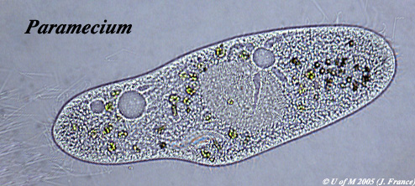
http://umanitoba.ca/Biology/BIOL1030/Lab1/biolab1_3.html#Ciliophora

- Below is an image of a paramecium. Label and annotate the image to indicate how it performs each of the functions of life.

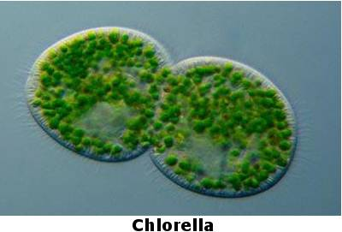
http://www.algae.info/Algaecomplete.aspx

1.1.U3 Surface area to volume ratio is important in the limitation of cell size.

- Explain why small cells are more efficient than big cells:

- As a cell grows in size eventually the metabolic rate increases beyond it’s ability to exchange materials and waste causing the cell to die. To prevent this increase in cell size is used as a trigger for cell division. The smaller cells restore a viable SA:vol.

  - What mechanisms other than cell division to cells use to maintain viable, efficient SA:Vol ratios?

  - What mechanisms other than cell division to multicellular organisms use to maintain viable, efficient SA:Vol ratios?

- Extension: describe how the invasive Caulerpa algae genus break the rules of SA:Vol (you will have to research this point – include your citations below your answer)

1.1.U4 Multicellular organisms have properties that emerge from the interaction of their cellular components.

- Unicellular organisms carry out all the functions of life, multi-cellular organisms differentiate and show emergent properties.
- Describe what is meant by the term emergent properties.

- Outline the advantages of cells differentiating to carry out specific functions.

1.1.U6 Differentiation involves the expression of some genes and not others in a cell’s genome.

- All cells in an organism share the same, identical, genome (i.e. they all possess the same genetic information).

  - In which type of cells is the entire genome active?

  - Describe how newly formed cells become specialised.

(Extension: refer to the packaging of genes in your answer)

1.1.U5 Specialized tissues can develop by cell differentiation in multicellular organisms.

- Collections of similar cells are called tissues. How many different distinct highly specialised cell types have been recognised in humans?

1.1.U7 The capacity of stem cells to divide and differentiate along different pathways is necessary in embryonic development and also makes stem cells suitable for therapeutic uses.

- Describe what is meant by the term stem cell.

- Define the following types of stem cells. Giving an example of each:

  - Totipotent

  - Pluripotent

  - Multipotent

  - Unipotent

1.1.A3 Use of stem cells to treat Stargardt’s disease and one other named condition.

- Complete the table to detail the use of stem cells in the treatment of specific conditions.

Condition | Stargardt's macular dystrophy
Outline the condition and the problems it causes | - Affects around one in 10,000 children  - Recessive genetic (inherited) condition  - The mutation causes an active transport protein on photoreceptor cells to malfunction  - The photoreceptor cells degenerate  - the production of a dysfunctional protein that cannot perform energy transport  - that causes progressive, and eventually total, loss of central vision
Describe treatment of the condition using stem cells
The benefit of using stem cells | Stem cells are currently the only viable treatment for this condition.

1.1.A4 Ethics of the therapeutic use of stem cells from specially created embryos, from the umbilical cord blood of a new-born baby and from an adult’s own tissues.

- Complete the table to compare the different sources of stem cells available:
 | Comparison of stem cell sources
 | Embryo | Cord blood | Adult
Differentiation | Can differentiate into any cell type | Limited capacity to differentiate (without inducement only naturally divide into blood cells)
Genetic damage |  |  | Due to accumulation of mutations through the life of the adult genetic damage can occur
Compatibility

- Therapeutic cloning remains a controversial area of medicine.
  - Outline the main arguments for therapeutic cloning

  - Outline the main arguments against therapeutic cloning

1.1.S1 Use of a light microscope to investigate the structure of cells and tissues, with drawing of cells. Calculation of the magnification of drawings and the actual size of structures and ultrastructures shown in drawings or micrographs. (Practical 1)

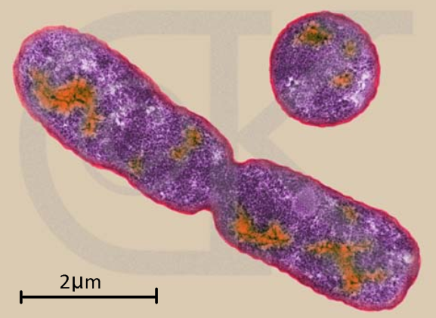
- The diagram below shows the characteristic rod-shaped structure of E. coli bacteria.
  - Calculate the magnification of the image.
  - State the method (shown here) by which bacteria reproduce.

- Calculate the actual size of the structures delineated in yellow.

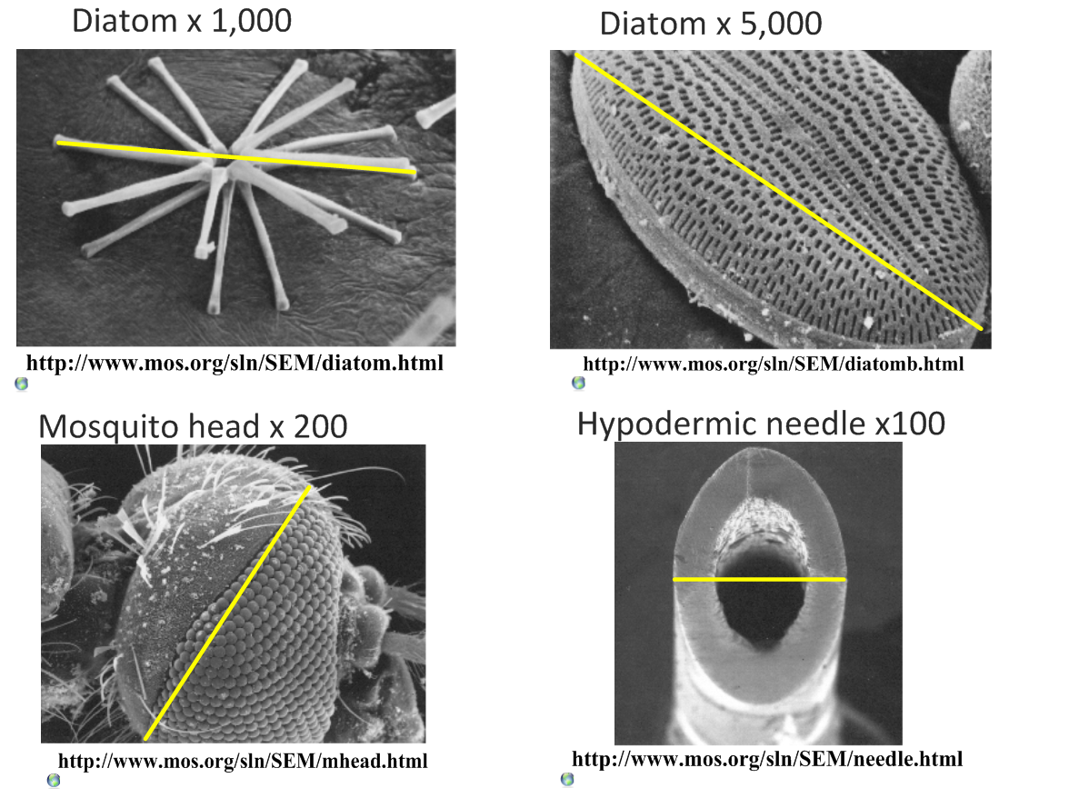

- Calculate the magnification of these scale bars:

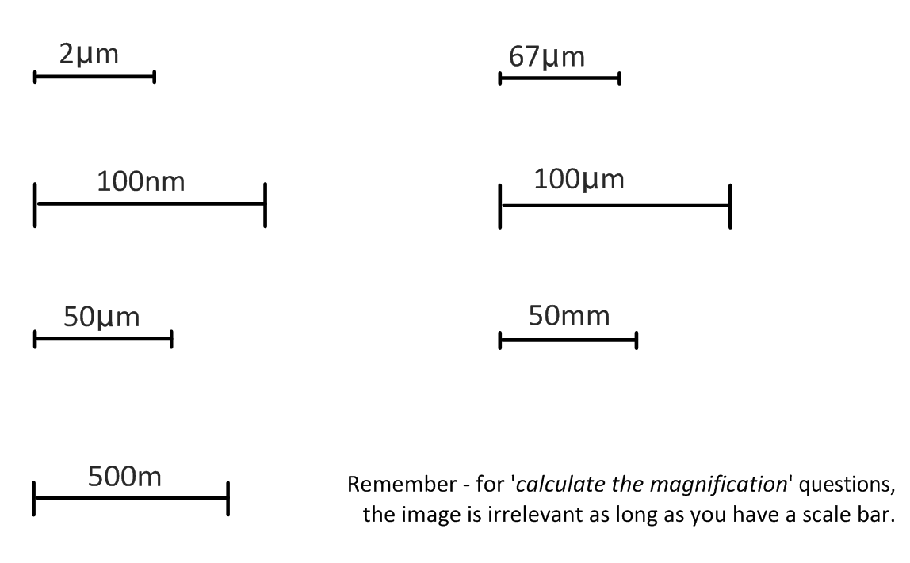

- What is the magnification of these images?

  - Scale bar 10µm measures 40mm on the image.

  - Scale bar 5µm measures 25mm on the image.

- A micrograph has a scale bar of 2µm, which measures 40mm on the image. Measuring the maximum length of the cell in the image, the ruler reads 180mm. How long is the cell?

- A student views an image of a cell magnified 350 times. The image is 250mm long. What is the actual length of the sample in the image?

Citations:
Allott, Andrew. Biology: Course Companion. S.l.: Oxford UP, 2014. Print.

Taylor, Stephen. "Essential Biology 02.1 Cell Theory.docx." Web. 17 Aug. 2014. <https://www.box.net/shared/r2o3scijx1>.

