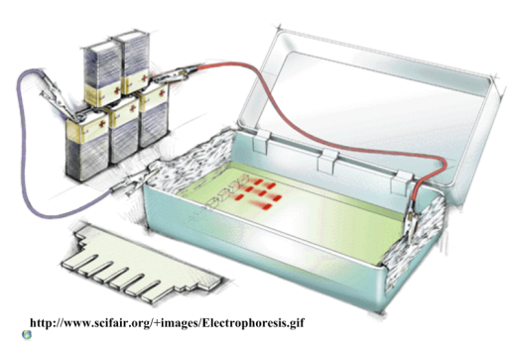
IB Biology: Biotechnology Review (3.5) NAME:
- What does PCR stand for?

- How is PCR useful in investigations?

- Outline briefly how gel electrophoresis works.

- What are two main uses of DNA profiling by electrophoresis?

- Use the gel electrophoresis results below to answer these questions.
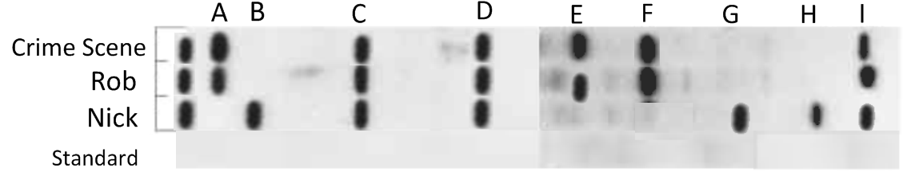

- Which criminal, Rob McCarr or Nick Allott, left their cigarette-end at the crime scene? How do you know?

- Color in bands to show where the ‘standard’ fragments would be observed.
- What evidence is there to suggest that Nick and Rob are related?

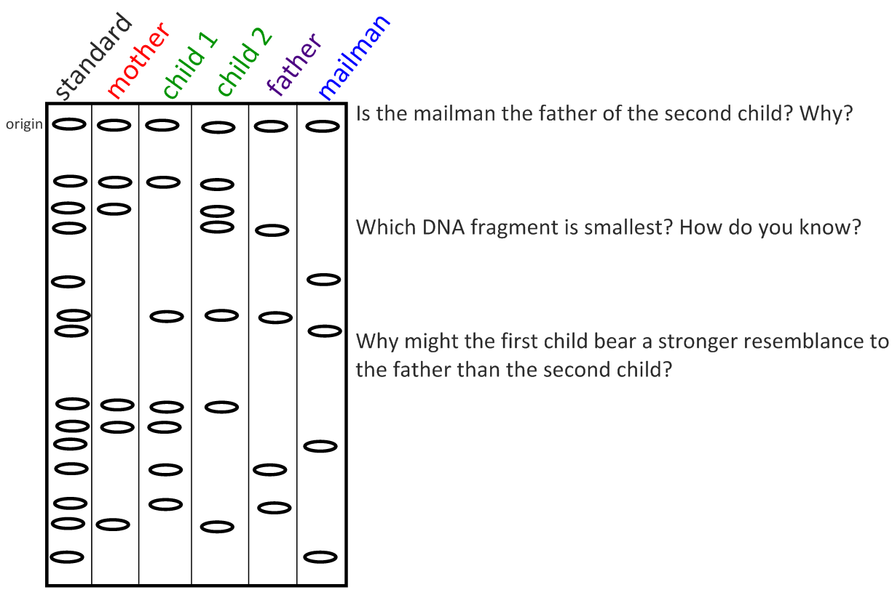
- This father thinks that the second child is not his – he looks too different from him! He has seen the mother and the mailman chatting and is suspicious. He stole some hair from all family members and swabbed a cup the mailman used and ran a gel electrophoresis to confirm his suspicions.

- What is meant by the term ‘the genetic code is universal’?

- What is a transgenic organism?
- Describe how a gene can be transferred into a bacteria using the terms restriction enzymes, plasmids, and DNA ligase:

- How is gene transfer used in industrial production of insulin?

- Give three examples of genetically modified plant crops and the effects of their new genes.
Named Example | Description
‘Golden Rice’

- Outline the potential benefits and risks of producing and consuming genetically-modified plants and animals:
 | Benefits | Risks
Health
Environment
Agriculture

- Define clone and give two naturally-occurring examples of clones:

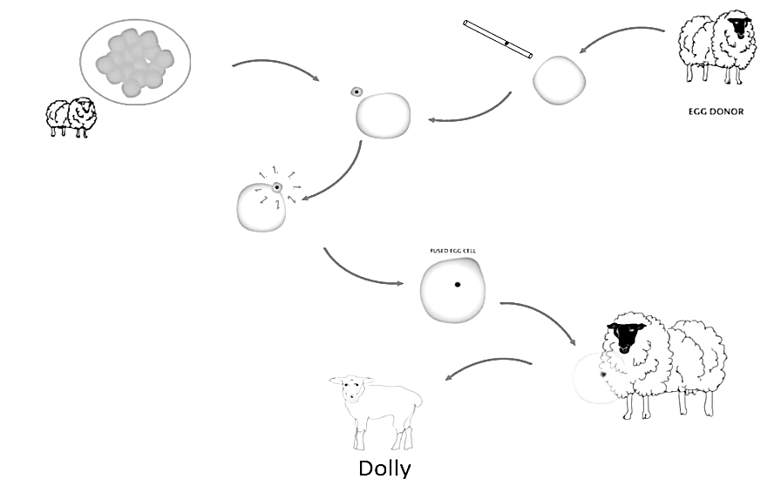
- Outline the method (SCNT- Somatic Cell Nuclear Transfer) used to clone Dolly the sheep by annotating the diagram to the right

- Distinguish between reproductive cloning and therapeutic cloning using SCNT.

