Chapter 17
The Tree of Life Lecture Guide
Day 1
Taxonomy
- What is taxonomy?
  - The science of ___________________________________
- Why should we classify organisms?
  - Provides a way to _____________________ unfamiliar organisms
  - Provides a way to _____________________ organisms
Aristotle
- 2000 years ago, Aristotle was the ____________________ taxonomist
- Aristotle divided organisms into _____________________________________.
- He subdivided them by their ________________________ (land, sea, or air dwellers)
Early Taxonomists
- John Ray, a botanist, was the first to use _____________________________ for naming
- His names were very long descriptions telling everything about the plant.
Carolus Linnaeus
- ______________________________________________ (classification)
- Divided organisms on the basis of __________________________________
- Created the 2-part system for naming and classifying organisms called ______________________________________________________________
Binomial Nomenclature
- ___________________________ words
- Language of Latin (it’s universal; whereas common names may be different)
- __________________________________(_________________________ the Genus, not the species)
- Must be _____________________________________
Homo sapiens or Homo sapiens
- Look at the example above
- Notice the first word, _________________________, is capitalized. The second is not.
- When writing a scientific name, always _________________________________ the genus only.
- Use italics or underlining to let others know it is a scientific name.
- By the way, Homo sapiens is a human!
More on Linnaeus
- Linnaeus also came up with a system for organizing ___________________________ types of organisms.
- Linnaeus’s system of classification uses ___________________ taxonomic categories…
- Each group or level of organization is called a taxonomic category or a _______________________.

Classification Timeline
- 2 Kingdom system accepted until 1866 when _______________________ proposed moving all single-celled organisms to the kingdom Protista
- 1938 – Copeland argued that the prokaryotes deserved their own kingdom called ___________________________
- 1959 – Whittaker proposed that because of how they feed, ___________________ should be placed into their own kingdom
- 1977 – Woese revealed two genetically different groups of prokaryotes splitting Monera into two kingdoms, ________________________________________
- Hierarchy-Taxonomic Groups
Domain
Kingdom
Phylum (Division – used for plants)
Class
Order
Family
Genus
Species
D K P C O F G S
- It helps to come up with a sentence using the first letter of each taxon to help you remember them. For example,
  - __________________________________________________________________
3 Domain System

Domains  These 2 kingdoms used to be combined into one called ________________. | Kingdoms
Bacteria | Eubacteria
Archaea | Archaebacteria
Eukarya | Protista  Fungi  Plantae  Animalia

Domains
- ________________________________, most inclusive taxon
- __________________ domains
- ______________________________________________ are unicellular prokaryotes (no nucleus or membrane-bound organelles)
- _______________________ are more complex and have a nucleus and membrane-bound organelles
THE 6 KINGDOMS
- ________________________________
- ________________________________
- ________________________________
- ________________________________
- ________________________________
- ________________________________
ARCHAEA
- Probably the __________________________ cells to evolve
- Live in ___________________________ environments
- Found in:
  - Sewage Treatment Plants
  - ________________________________________________________
  - Hot Springs or Geysers that are acid
  - Very salty water (Dead Sea; Great Salt Lake)
EUBACTERIA
- Some may cause _______________________________________
- Found in ____________________________________ except harsh ones
- Important _________________________________ for environment
- Commercially important in making cottage cheese, yogurt, buttermilk, etc.
Domain Eukarya is divided into Kingdoms
- _______________________________ (protozoans, algae…)
- _______________________________ (mushrooms, yeasts …)
- _______________________________ (multicellular plants)
- _______________________________ (multicellular animals)
Protista
- Most are ________________________________
- Some are multicellular
- Some are _____________________________, while others are heterotrophic
- Aquatic

Fungi
- Multicellular, except ___________________________________________
- Absorptive heterotrophs (____________________________________________________________________)
- Cell walls made of _____________________________
Plantae
- Multicellular
- Autotrophic
- Absorb _______________________________________________
- Cell walls made of ______________________________________
Animalia
- Multicellular
- Ingestive heterotrophs (______________________________________________________________________)
- Feed on plants or animals
Dichotomous Keying
- Used to ________________________________ organisms
- Characteristics given in ______________________________
- Read both characteristics and either go to ___________________________________ of characteristics OR ______________________________ the organism

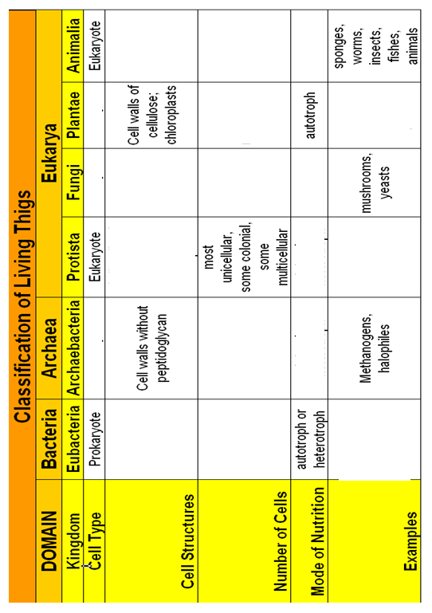

Chapter 17
The Tree of Life Lecture Guide
Day 2

Problems with Traditional Classification
- During Linnaeus’s time, scientists classified organisms based on their ___________________________________________________, but today we know that doesn’t always work!
  - Example: dolphins -> fish or mammals?
- Remember, ____________________________________________ -> sometimes organisms that are different from each other evolve _______________________________ body structures, due to the change in the environment.
Evolutionary Classification
- Biologists now group organisms into categories that represent lines of _________________________________________________, not just physical features.
  - Evolutionary classification – is the strategy of grouping organisms together based on their _______________________________________________.

Traditional versus Evolutionary Classification

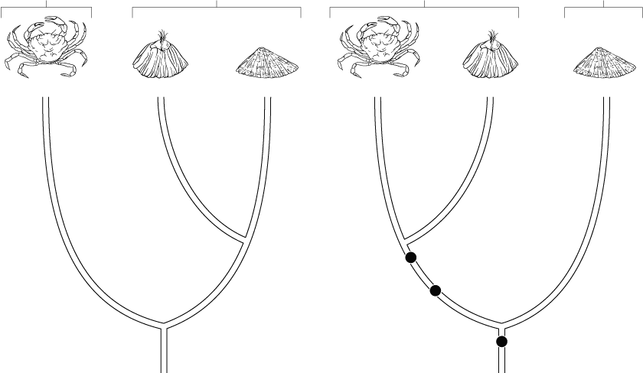
Tiny free swimming larvae
Segmentation
Molted Exoskeleton

Evolutionary relationships
- These provide clues and information about how species evolved.
- They are determined on basis of:
    - ________________________________________
    - ________________________________________
    - ________________________________________
    - ________________________________________
    - ________________________________________
I. Structural Similarities:
  - Imply that species are ____________________________________ and may have evolved from same ancestor
    - Examples:
      - Dandelions/Sunflowers
      - Bobcat/Lynx
II. Breeding Behavior:
  - Patterns of ______________________________________________
    - Examples:
      - Frogs
III. Geographical Distribution:
  - _________________________________________ despite geographic isolation
    - Examples:
      - Galapagos Island Finches
IV. Chromosomal Comparisons:
  - Species may look different but have chromosomes that are _______________________________________ in structure
    - Example: Cauliflower, Cabbage, Broccoli
V. Biochemistry:
  - Studying DNA sequences, proteins, nucleotides in different organisms
  - If their DNA sequences and proteins are more alike, then probably the organisms are _____________________________________________.
Classification using Cladograms
- To refine evolutionary classification, biologists now prefer a method called cladistics.
  - Cladogram – a _______________________________ that shows the evolutionary relationships among a group of organisms; includes ______________________________________________ that arise as lineages evolve.
    - Characteristics that appear in recent parts of a lineage but not in its older members are called __________________________________________
Now let’s see if you can do it….
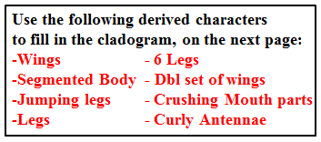
***Make sure you can identify all of the different terms we discussed in our previous notes AFTER you finish your cladogram (don’t worry…we will do this together in class

