Chapter 1, Science and the Environment
Section 1: Understanding Our Environment Day 1
What Is Environmental Science?
- ____________________________________________________ is the study of the air, water, and land surrounding an organism or a community, which ranges from a small area to Earth’s entire biosphere.
- It includes the study of the impact of _______________________________________________________________________.
What is the Goal of Environmental Science?
- A major goal of environmental science is to _______________________________________________________________________.
- To accomplish this goal, environmental scientists study two main types of interactions between humans and their environment:
  - ________________________________________________________________.
  - 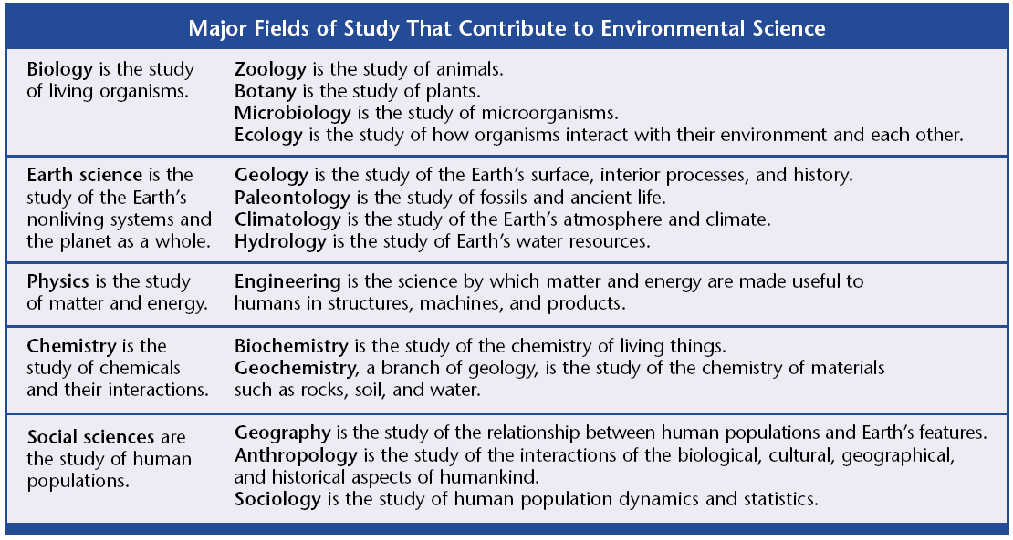________________________________________________________________
Many Fields of Study
- Environmental science is an interdisciplinary science, which means that it involves many fields of study.
- ________________________________ is they study of interactions of living organisms with one another and with their environment.
- ________________________________ is the study of living things.
- ________________________________ is the study of chemicals and their interactions.
- ________________________________ is the study of matter and energy.

Scientists as Citizens, Citizens as Scientists
- However, the __________________________________________________________ are the first steps toward addressing an environmental problem.
First Impact: Hunter-Gatherers
- ________________________________________________ are people who obtain food by collecting plants and by hunting wild animals or scavenging their remains.
- Hunter-gatherers affect their environment in many ways:
  - Native American tribes ______________________________________________.
  - The tribes also set _________________________________________________________________. This left the prairie as an open grassland ideal for hunting bison.
- In North America, a combination of rapid climate changes and overhunting by hunter-gatherers may have led to the disappearance of some large mammal species, including:
  - __________________________________
  - __________________________________
  - __________________________________
  - __________________________________
  - __________________________________
The Agricultural Revolution
- _________________________________________ is the raising of crops and livestock for food or for other products that are useful to humans.
- The practice of agriculture started in many different parts of the world over _______________________________________ ago.
- The change had such a dramatic impact on human societies and their environment that it is often called the ________________________________________________________.
- As populations grew, they began to ______________________________________________________________________ on the local environments.
- The plants we grow and eat today are descended from ________________________________.
- However, during harvest season farmers collected seeds from plants that exhibited the qualities they desired, such as ________________________________________.
- Replacing forest with farmland on a large scale can cause _____________________________________________________________________.
- The ________________________________________________ technique was one of the earliest ways that land was converted to farmland.
The Industrial Revolution
- The Industrial Revolution involved a shift from energy sources such as ______________________________________________________________________.
- This increased use of fossil fuels changed society and greatly increased the efficiency of ______________________________________________________________________.
Graphic Organizer: Our Environment Through Time

- Please put the graphic organizer below. It will be part of your notebook check.
- The instructions for the graphic organizer are located on page 9 of your textbook.
- Comparison table instructions are located in the appendix (back of the book) on page 616.

Chapter 1 Science and the Environment
Section 2: The Environment and Society Day 1
“The Tragedy of the Commons”
- In his essay, ecologist ________________________________________ argued that the main difficulty in solving environmental problems is the conflict between the short-term interests of the individual and the long-term welfare of society.
- The example he used was the __________________________________, or the areas of land that belonged to the whole village.
“The Tragedy of the Commons”
- The commons were eventually replaced by _____________________________________________________________________.
- Hardin’s point being that ______________________________________________________________________.
“The Tragedy of the Commons”
- Humans live in societies, and in societies, we can solve environmental problems by ______________________________________________________________________.
Supply and Demand
- ______________________________________________________ is a law of economics that states as the demand for a good or service increases, the value or the food or service also increases.
- An example is the world _______________________________________________.
Costs and Benefits
- A _________________________________________ balances the cost of the action against the benefits one expects from it.
- For example, pollution control may be too costly to an industry, but to a nearby community, the price may well be worth it.
- Often, environmental regulations are passed on to ______________________________________________________.
Risk Assessment
- One of the costs of any action is the risk of an undesirable outcome.
- _______________________________________________ is a tool that helps us create cost effective ways to protect our health and environment.

Developed and Developing Countries
- ________________________________________ have higher incomes, slower population growth, diverse industrial economies, and stronger social support.
- ________________________________________ have lower average incomes, simple agriculture-based communities, and rapid population growth.
Population and Consumption
- Almost all environmental problems can be traced back to two root causes:
  - ____________________________________________________________________________________________________________________________________
  - ____________________________________________________________________________________________________________________________________
Local Population Pressures
- In ____________________________________________, millions of people are starving.
Consumption Trends
- To support the higher quality of life, ________________________________________ are using much more of Earth’s resources.
- Developed nations use about _____________ percent of the world’s resources, although they make up only ________________ percent of the world’s population.
Ecological Footprints
- __________________________________________________ are calculations that show the productive area of Earth needed to support one person in a particular country.
- An ecological footprint estimates the land used for ______________________________________________________________________.
Ecological Footprints
- An ecological footprint is one way to express the
_________________________________________________.

Critical Thinking and the Environment
- Remember a few things as you explore environmental science further:
  - ____________________________________________________________________________________________________________________________________
  - ____________________________________________________________________________________________________________________________________
  - ____________________________________________________________________________________________________________________________________
A Sustainable World
- ___________________________________________ is the condition in which human needs are met in such a way that a human population can survive indefinitely.
Chapter 1 Science and the Environment
Section 1: Understanding Our Environment Day 2

Our Environment through Time Continued: Improving the Quality of Life
- The ______________________________________________________ introduced many positive changes such as the light bulb.
- Agricultural productivity _____________________________, and sanitation, nutrition, and medical care vastly ______________________________.
Improving the Quality of Life
- However, the Industrial Revolution also introduced many new environmental problems such as _____________________________________________.
- In the 1900s, modern societies began to use ___________________________________ in place of raw animals and plant products.
- As a result, we know have materials such as ______________________________________________________________________.
Spaceship Earth
- Earth is essentially a ______________________________________.
- This means that the only thing that enters the Earth’s atmosphere in large amounts is _____________________________________________, and the only thing that leaves in large amounts is ________________________________.
- Environmental problems can occur on different scales: _____________________________________________________________________.
  - A local example would be your community discussing where to build a new _______________________________________.
  - A regional example would be a polluted river ______________________________________________________________.
  - A global example would be the ______________________________________________________________.
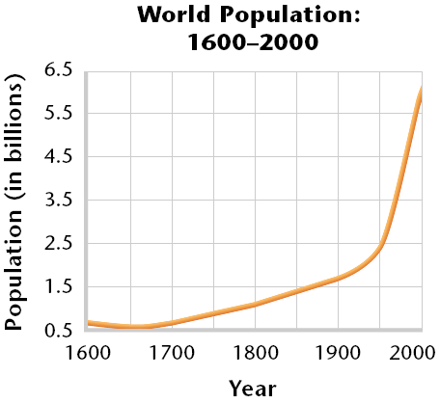Population Growth
- The Industrial Revolution, modern medicine, and sanitation all allowed the human population to ______________________________________ than it ever had before.
Population Growth
- Producing enough food for large populations has environmental consequences such as __________________________________________________.
What are our Main Environmental Problems?
- Environmental problems can generally be grouped into three categories:
  - ____________________________________________ _____________________________________________
  - ____________________________________________
Resource Depletion
- __________________________________________ are any natural materials that are used by humans, such as, water, petroleum, minerals, forests, and animals.
- 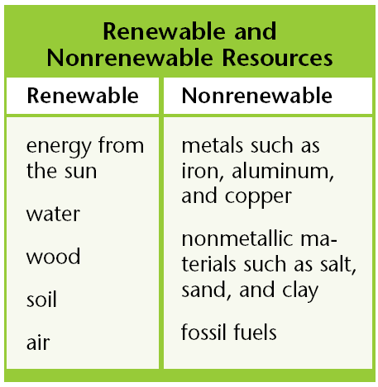Natural resources are classified as either a _____________________________________________________.
- _______________________________________________ can be replaced relatively quickly by natural process.
- _______________________________________________ form at a much slower rate than they are consumed.
- Resources are said to be ___________________________ when a large fraction of the resource has been used up.
- Once the supply of a nonrenewable resource has been used up, it may take millions of years to replenish it.
Pollution
- ______________________________________ is an undesirable change in the natural environment that is caused by the introduction of substances that are harmful to living organisms or by excessive wastes, heat, noise, or radiation
- Much of the pollution that troubles us today is produced by _____________________________________________________________________.
- There are two main types of pollutants:
  - _______________________________________________, which can be broken down by natural processes and include materials such as newspaper.
  - _______________________________________________, which cannot be broken down by natural processes and include materials such as mercury.
- Degradable pollutants are a problem only when they ____________________________________________ than they can be broken down.
Loss of Biodiversity
- __________________________________________ is the variety of organisms in a given area, the genetic variation within a population, the variety of species in a community, or the variety of communities in an ecosystem.

