Concluding – Aspect 1 (Conclusion and Evaluation)

The conclusion starts with one (or more) paragraphs in which students draw conclusions from results, and state whether or not the conclusions support the hypothesis. The conclusion should be clearly related to the research question and the purpose of the experiment. Students must also provide a brief explanation as to how they came to the conclusion from the results. In other words, sum up the evidence and explain observations, trends or patterns revealed by the data.
When measuring an already known and accepted value, students should indicate their confidence in the result by comparing the experimental value with the textbook or literature value. The literature consulted should be fully referenced.

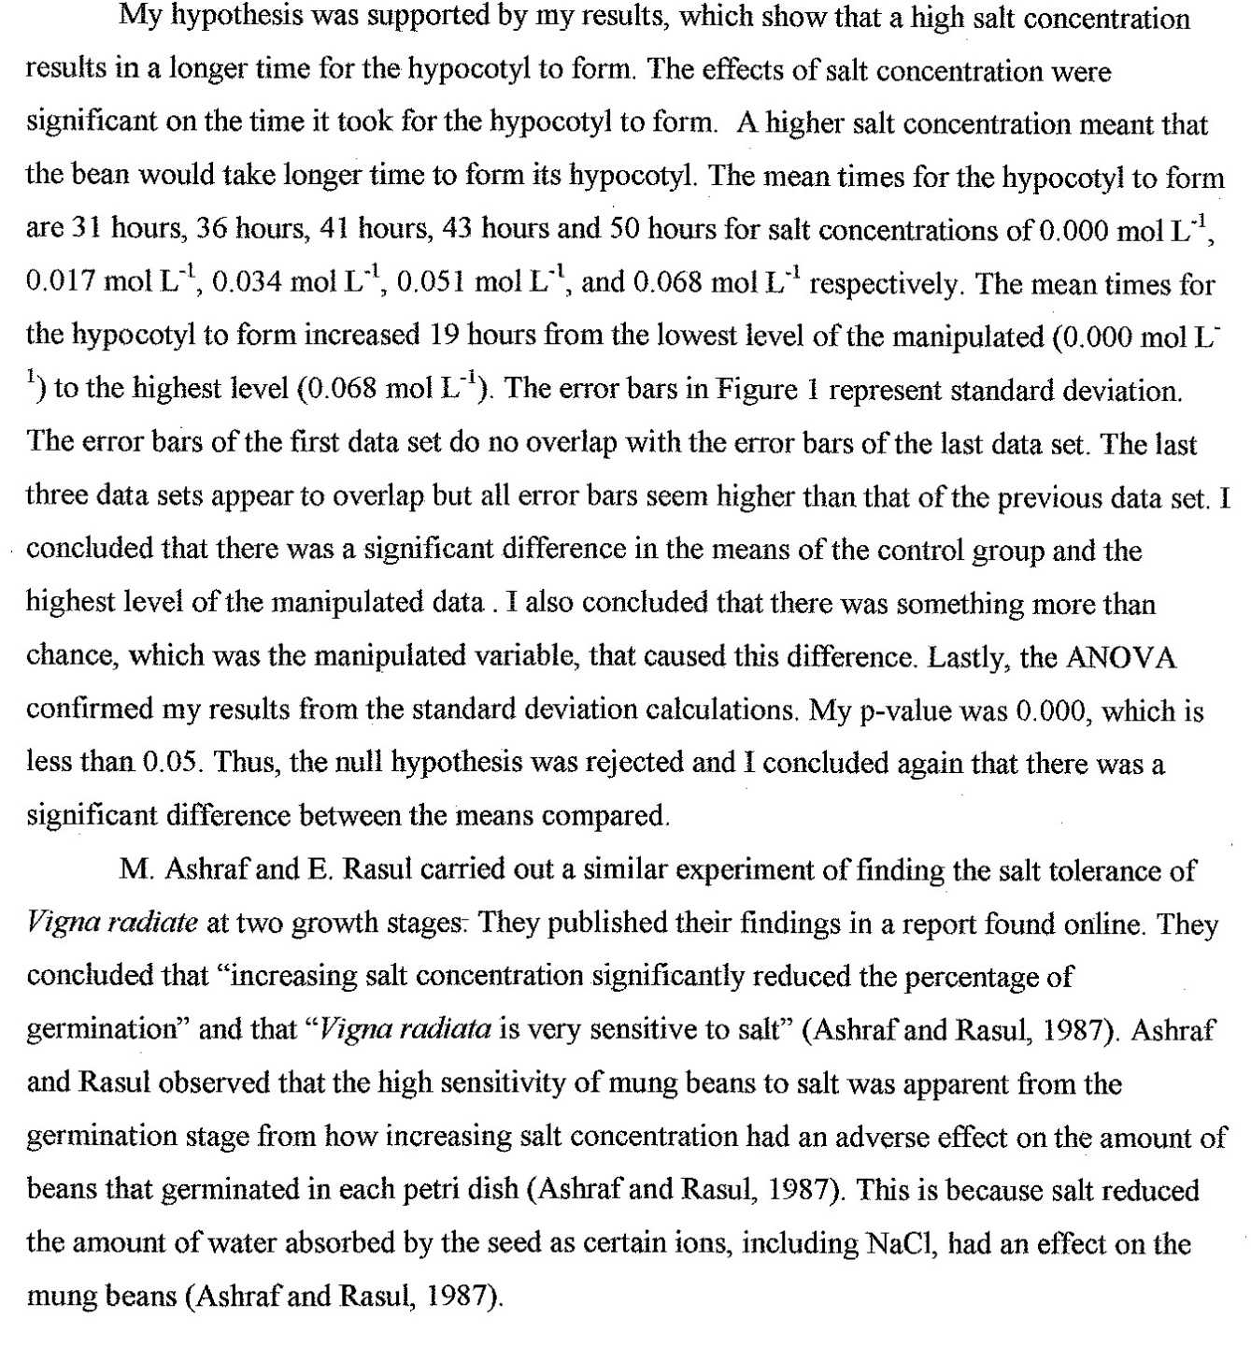

Evaluating Procedures – Aspect 2 (Conclusion and Evaluation)

The design and method of the investigation must be commented upon as well as the quality of the data. Students should consider how large the errors or uncertainties are in the results. How confident are they in the results? Are they fairly conclusive, or are other interpretations/results possible?
Identify and discuss significant errors and limitations that could have affected the outcome of the experiment. See the pages on statistics and graphing for help in determining significance. Were there important variables that were not controlled? Were there flaws in the procedure which could affect the results? Are measurements and observations reliable? Was there a lack of replication?
Emphasis in this section should be on systematic errors, not the random errors that always occur in reading instruments and taking measurements. Identify the source of error and if possible, tie it to how it likely affected the results.
Acceptable Example:
“Because the simple calorimeter we used was made from a tin can, some heat was lost to the surroundings—metals conduct heat well. Therefore, the value we obtained for the heat gained by the water in the calorimeter was lower than it should have been.”
Unacceptable Examples:
"The test tubes weren’t clean.”
“Human error.”
Students must not only list the weaknesses but must also appreciate how significant the weaknesses are. Comments about the precision and accuracy of the measurements are relevant here. When evaluating the procedure used, the specifically look at the processes, use of equipment and management of time.

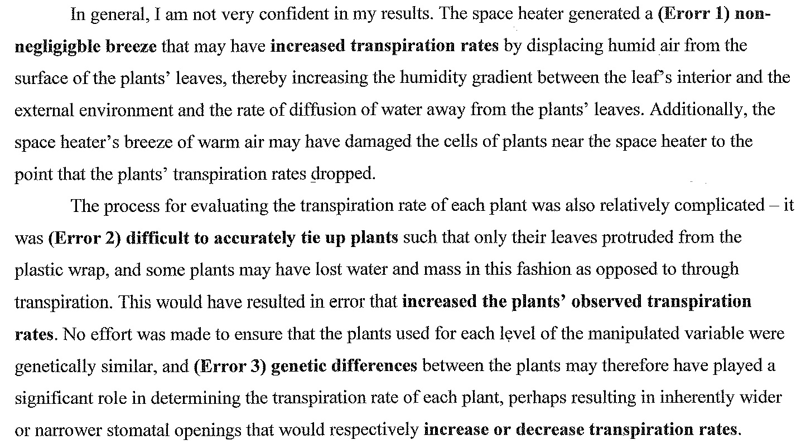

Improving Investigations – Aspect 3 (Conclusion and Evaluation)

Suggestions for improvements should be based on the weaknesses and limitations identified in aspect 2. Modifications to the experimental techniques and the data range can be addressed here. The modifications proposed should be realistic and clearly specified. Suggestions should focus on specific pieces of equipment or techniques used. It is not sufficient to state generally that more precise equipment should be used. Vague comments such as “I should have worked more carefully” are not acceptable.

