Defining the Problem and Selecting Variables – Aspect 1 (Design)
Background –

Write a paragraph or two explaining why the experiment is relevant to the study of biology. How does it relate to what is being learned in class? What process or phenomenon will the experiment support?

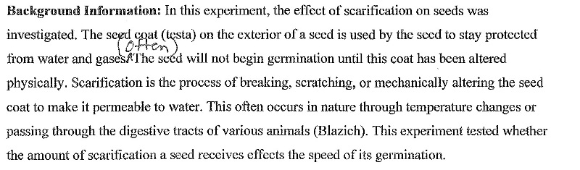

Research Question –

This is a single sentence which clearly and specifically states the objective of the investigation. For a Design lab, the teacher cannot give detailed information and guidance. Instead, students are given a general, open-ended problem such as “Investigate the factors that affect X”. Students must do some thinking to recognize the nature of the problem that has been set, the factors (variables) that will affect the outcome, and how they affect it (the hypothesis). If doing a controlled experiment, the research question must clearly identify the manipulated and responding variables or the experiment.

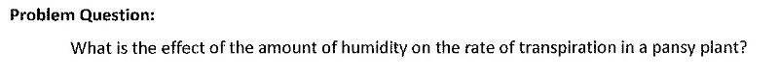

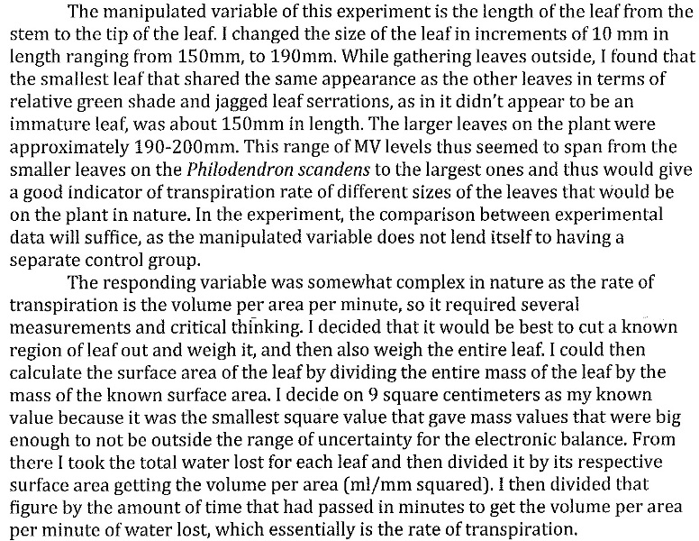
Selecting Variables –

State variables explicitly, and explain why each is relevant. All reasonable variables that might affect the outcome should be identified. Indicate which variable(s) is/are manipulated variables (ones that are changed) and which are the responding variables (ones that will respond to what was done). Indicate which variables must be controlled and why those variables must be controlled. Relevant controlled variables are those that can reasonably be expected to affect the outcome.

Hypothesis –

Although not required by the IB Organization, for many labs students are asked to include a hypothesis. A hypothesis is like a prediction. It will often take the form of a proposed relationship
between two or more variables that can be tested by experiment: “If X is done, then Y will occur.” (Examples: “The rate of transpiration will increase as wind speeds and temperatures rise” or “Brand
X toothpaste will be more effective in preventing the growth of the bacteria which causes plaque on teeth”). Also provide an explanation for the hypothesis. This should be a brief discussion (paragraph form) about the theory or ‘why’ behind the hypothesis and prediction. Be sure the hypothesis is related directly to the research question and that the manipulated and responding
variables for the experiment are clear.

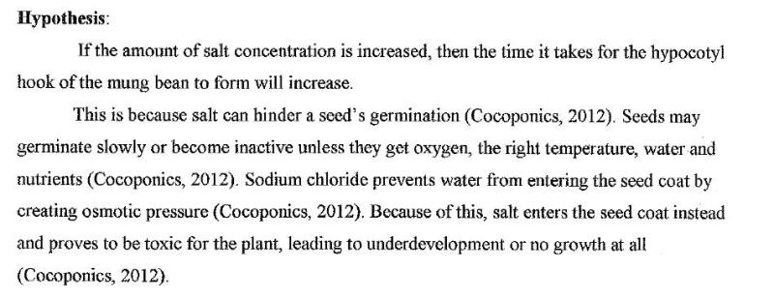

Controlling Variables – Aspect 2 (Design)

“Control of variables” refers to the manipulation of the independent variable and the attempt to
maintain the controlled variables at a constant value. Students should write a paragraph in which they describe how the control of variables is achieved. If the control of variables is not practically possible, some effort should be made to monitor the variable(s). State an explicit procedure or method for how each variable will be controlled and monitored. (For example, if the temperature must remain constant, figure out how you will do this and state it. Perhaps you might use a water bath that is maintained at a certain temperature. Or perhaps the amount of light must remain constant. In this case, you might take light readings before and after the experiment).

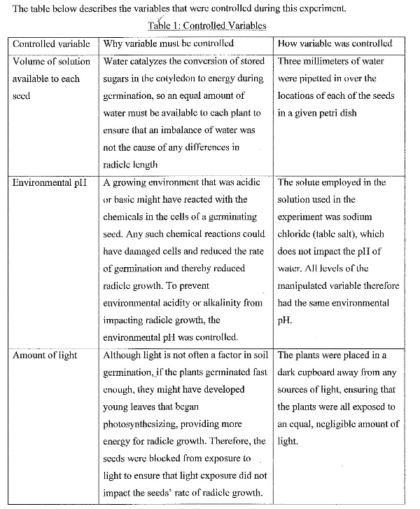

Developing a Method for Collecting Data Aspect 3 (Design)

Apparatus and Materials

Consider making a list of materials needed. Be as specific as possible. (Example: “50 mL beaker instead of ‘beaker’, type of microscope with magnification range). A diagram or photograph of how the experiment is set up may be appropriate, especially for more complicated experiments. Be sure the diagram includes a title and any necessary labels. You might have to decide how much of a substance or a solution to use. If so, state your reasoning or show the calculations.

Method and Procedure

State or discuss the method (procedure) that was used in the experiment. This can be in the form of a list of step-by-step directions or a narrative. Provide enough detail so that another person could repeat your work by reading the report! You don’t have to go into detail about standard,
well-understood actions such as measuring a temperature with a thermometer, weighing out a substance, etc. If a standard technique is used, it should be referenced. For example, while planning an investigation to study the effect of light wavelength on the rate of photosynthesis in Cabomba, the student may have adapted a method to measure the rate of photosynthesis taken from a textbook. A standard reference would then be expected as a footnote, for example, “Freeland, PW (1985) Problems in Practical Advanced Level Biology, Hodder and Stoughton.” Or the student may adapt a general protocol provided by a teacher in a previous investigation. The reference may appear as: von Bargen, G (2013) “Studying the rate of photosynthesis” worksheet.
If something is done in the procedure to minimize an anticipated error, mention this as well. (Example: “Carefully cutting plant stem under water to reduce effect of air on transpiration
rate.”)
In the method, clearly state how to collect data. What measuring device was used, what data was recorded and when? Or what qualitative observations were looked for (such as color change)?

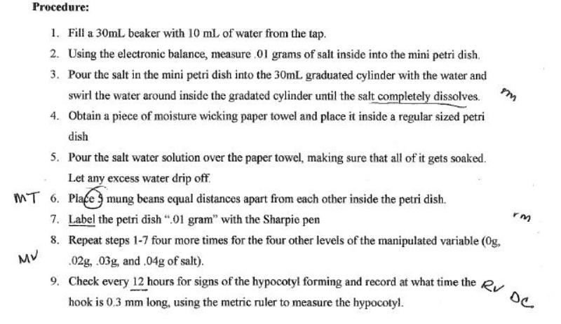

Multiple Trials –
The procedure must allow collection of sufficient relevant data. The definition of “sufficient relevant data” depends on the context. The planned investigation should anticipate the collection of sufficient data so that the aim or research question can be suitably addressed and an evaluation of the reliability of the data can be made. As a rule, the lower limit is five measurements, or a sample size of five. Very small samples run from 5 to 20, small samples run from 20 to 30, and big samples run from 30 upwards. Obviously, this will vary within
the limits of the time available for an investigation.
The data range and amount of data in that range are also important. For example, when trying to
determine the optimum pH of an enzyme, using a range of pH values between 6 and 8 would be insufficient. Using a range of values between 3 and 10 would be better, but would also be insufficient if only three different pH values were tested in that range.
Safety
List any safety precautions that must be taken during the lab. For example,
- “Wear safety goggles throughout experiment.”
- “Be cautious in using strong acids/bases. Rinse off spills with water immediately.”
- “Avoid breathing vapors of automobile exhaust.”

