Graphing Mean and Standard Deviation using a Line Graph in Excel 2010
Use the average and standard deviation (stdev) functions and the fill handle to copy formulas
Make sure your data is displayed in a logical manner.
In this exercise we have our data displayed in a row format with two groups - Group 1 and Group 2.
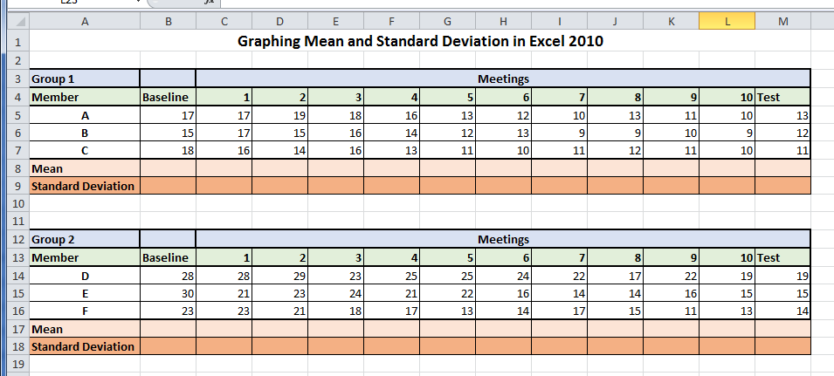
- Step 1: We will begin by calculating the mean for Group 1
Select cell B8 type the =average(
- Select your data points you want included in the calculation – B5:B7 Close parenthesis ) then enter.
Follow the above steps and calculate the mean for Group 2
Step 2: Calculate the Standard Deviation for Group 1 and Group 2.
- Type the = sign and stde (you will see that as you begin typing the name of the function a list of possible matches will appear. Dbl click the STDEV function to insert it into the formula, a parenthesis has also been inserted.)
- Select the data points for Group 1
- Close the parenthesis ) and then enter
Follow the same steps above to calculate the standard deviation for Group 2.
Step 3 - Use the fill handle to copy the formulas for mean and standard deviation across to the other cells.
First select the cells that contain the formula that you want to fill into the adjacent cells.
- Select cells B8 and B9 - The fill handle will appear as a black plus sign when you hover over the lower right corner of the selected cells.
- Drag the fill handle across the cells that you want to fill.
Step 4 - Creating a line graph with custom Standard Deviation error bars.
Create a line chart. To initiate the line chart in excel, you will need to select the data range to include in the chart.
- Click on cell B8 and drag to select the range of averages aka the Mean.
- Next while holding down the CTRL key, click and drag to select the second range of cells for Group 2 – so click in cell B17 and drag.
- Click the insert tab,
- Click on the Line menu showing the different types of line charts.
- Choose the Marked Line option. (above the 3-D line)
A rough version of the chart will appear.
- To edit the data series, click the “select data” icon.
By default – excel names the data series – Series 1 and Series 2
- Give the series a more descriptive name by clicking the “edit” button.
- Make sure the cursor is in the Series name box
- Then click the cell containing the label “Group 1”
- Click ok to add the series name.
Follow the same steps to add a name to series 2.
- First select series 2 then click edit
- with your cursor in the series name box click the cell containing the words “Group 2”
- Click ok to finish adding the series name.
If you look closely at the horizontal axis labels you will see that those labels do not match up with the labels that are in our data table.
Add the proper labels from our data table to the chart
- Click the edit button under the horizontal axis table
- Click the collapse button in the axis label dialog box
- Then click your cursor in the starting cell for “Baseline” and drag it across all the way to the end cell “Test”. These will become the labels.
- Click the expand button to access the full menu.
- Click “ok” to finish adding the labels.
- And click “ok” to finish and close the dialog.
Adding custom Standard Deviation error bars to a chart
- Select the first series you want to work with.
- Start with Group 1 so click the BLUE Line.
- Click the “Layout” tab from the “Chart Tools” menu.
- From the “analysis Group” click the “Error Bars” button.
- From the menu that appears, click the “More Error Bars Option”.
- From the menu that appears, click the “Custom” radio button.
- To tell Excel what numbers to use click the “Specify Value” button.
- To select the positive error value first click the collapse button.
- Then select the entire range of Standard Deviation that we calculated earlier for Group 1.
- Click the expand button to see the entire menu.
Grab the same values for the negative errors value.
- Click the collapse button. Then select the entire range for SD that we calculated for Group 1.
- Click the expand button to access the full menu.
- Click ok to finish entering the custom error bar values.
- Click the close button to exit the dialogue.
Repeat the process to add the error bars for Group 2.
- Click on the Red Group 2 line.
- Click the “error bars” button from the analysis Team on the “layout” tab.
- Click “More Error Bars Options” from the menu that appears.
- Click the “Custom” radio button.
- Then the “Specify Value” button.
- Select the Standard Deviation with that menu uncollapsed.
To add positive error value.
- Click the first value and drag across to the last one.
- To add the negative error value. Click the collapse button.
- Click and drag across to select the entire range for Standard Deviation for Group 2.
- Click the expand button to see the full menu.
- Click ok to finish adding the values.
- Click “Close”
Custom error bars allows us to better see the relationship between the “Average” and the “Standard Deviation” values for this data.
Adding chart titles and axis title
First move the chart to a new page.
- Right click on the chart area and select “Move Chart” from the menu that appears.
- The move chart menu will appear, click “New Sheet”.
- Name your sheet and click “OK” to finish.
Adding Titles to your Chart
- Click on the “Layout” tab under “Chart Tools” to add your titles.
- Click the “Chart Title” icon in the labels Group.
- Choose the “Above Chart” option from the menu that appears.
- Type a Descriptive title for your chart then press “enter” to finish.
Now add the “Axis Titles”
- Click the “Axis Title” icon
- Choose “Primary Horizontal Axis Title” from the menu that appears.
- Then choose the “title below axis” option
- Type a description for the axis title and press enter.
To add the “Vertical Axis Title”
- Click the “Axis Title” then choose “Primary Vertical Axis Title”
- Then choose “Rotated Title”
- Type a description of the axis title and press enter.
You can change the format for the titles by clicking on the title and going to the Home tab and choose the options you would like to add.

