Food Chains and Webs --- "What's for dinner?"
Every organism needs to obtain energy in order to live. For example, plants get energy from the sun, some animals eat plants, and some animals eat other animals.
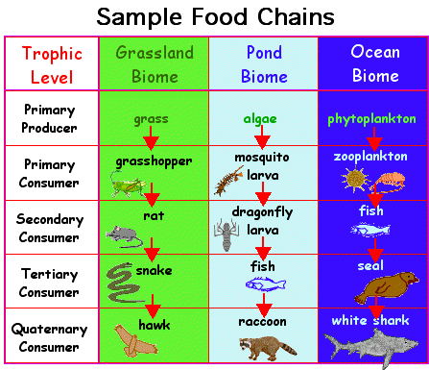
A food chain is the sequence of who eats whom in a biological community (an ecosystem) to obtain nutrition. A food chain starts with the primary energy source, usually the sun or boiling-hot deep-sea vents. The next link in the chain is an organism that makes its own food from the primary energy source -- an example is photosynthetic plants that make their own food from sunlight (using a process called photosynthesis) and chemosynthetic bacteria that make their food energy from chemicals in hydrothermal vents. These are called autotrophs or primary producers.

Next come organisms that eat the autotrophs; these organisms are called herbivores or primary consumers -- an example is a rabbit that eats grass. The next link in the chain is animals that eat herbivore - these are called secondary consumers -- an example is a snake that eats rabbits. In turn, these animals are eaten by larger predators -- an example is an owl that eats snakes. The tertiary consumers are eaten by quaternary consumers -- an example is a hawk that eats owls. Each food chain ends with a top predator and animal with no natural enemies (like an alligator, hawk, or polar bear).
Food Chain Questions
- What travels through a food chain or web?
- What is the ultimate energy for all life on Earth?
- Food chains start with what?
- The 1st organism in a food chain must always be what type of organism?
- Name 2 food making processes.
- Where do chemosynthetic bacteria get their energy?
- Define herbivore.
- Herbivores are also called _________________________.
- What are animals called that feed on herbivores?
- Secondary consumers are eaten by larger ________________.
- _________________ consumers eat secondary consumers.
- Make a food chain with a producer and 3 consumers.

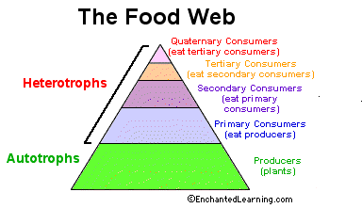
The arrows in a food chain show the flow of energy, from the sun or hydrothermal vent to a top predator. As the energy flows from organism to organism, energy is lost at each step. A network of many food chains is called a food web.
Trophic Levels:
The trophic level of an organism is the position it holds in a food chain.
- Primary producers (organisms that make their own food from sunlight and/or chemical energy from deep sea vents) are the base of every food chain - these organisms are called autotrophs.
- Primary consumers are animals that eat primary producers; they are also called herbivores (plant-eaters).
- Secondary consumers eat primary consumers. They are carnivores (meat-eaters) and omnivores (animals that eat both animals and plants).
- Tertiary consumers eat secondary consumers.
- Quaternary consumers eat tertiary consumers.
- Food chains "end" with top predators, animals that have little or no natural enemies.
When any organism dies, it is eventually eaten by detrivores (like vultures, worms and crabs) and broken down by decomposers (mostly bacteria and fungi), and the exchange of energy continues.
Some organisms' position in the food chain can vary as their diet differs. For example, when a bear eats berries, the bear is functioning as a primary consumer. When a bear eats a plant-eating rodent, the bear is functioning as a secondary consumer. When the bear eats salmon, the bear is functioning as a tertiary consumer (this is because salmon is a secondary consumer, since salmon eat herring that eat zooplankton that eat phytoplankton, that make their own energy from sunlight). Think about how people's place in the food chain varies - often within a single meal!
Food Web Questions
- What is used to indicate the flow of energy in a food chain or web?
- What happens to energy as we move from step to step in a chain or web?
- Define food web.
- What is meant by trophic levels?
- Define autotroph.
- The 1st trophic level consists of _______________ producers called _________________.
- Name the 2nd trophic level (both names).
- Secondary consumers may be _______________ eating meat or _______________ that eat both plants and animals.
- What is the 3rd trophic level called?
- What is the 4th trophic level called?
- At the 5th trophic level would be _____________ consumers that eat _____________ consumers.

